**Kubernetes Task-2**

**Task Description:**

Create the K8s EKS,further you have to do the deployment of the Nginx application and access the application outside the cluster.

Explanation:

1. Login to AWS console, search for EKS service and open Amazon Elastic Kubernetes Service (EKS).

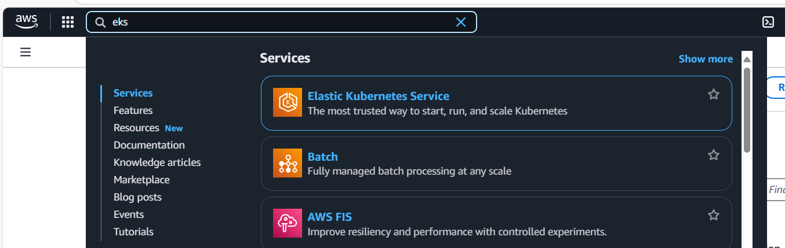

1. Create cluster

Click create cluster.

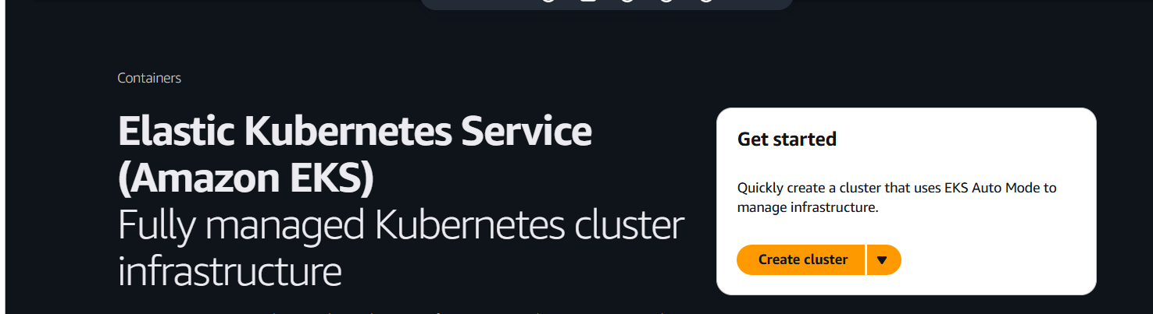

Name : my-eks-cluster

Choose the version

Create or choose the IAM with AmazonEKSClusterPolicy.

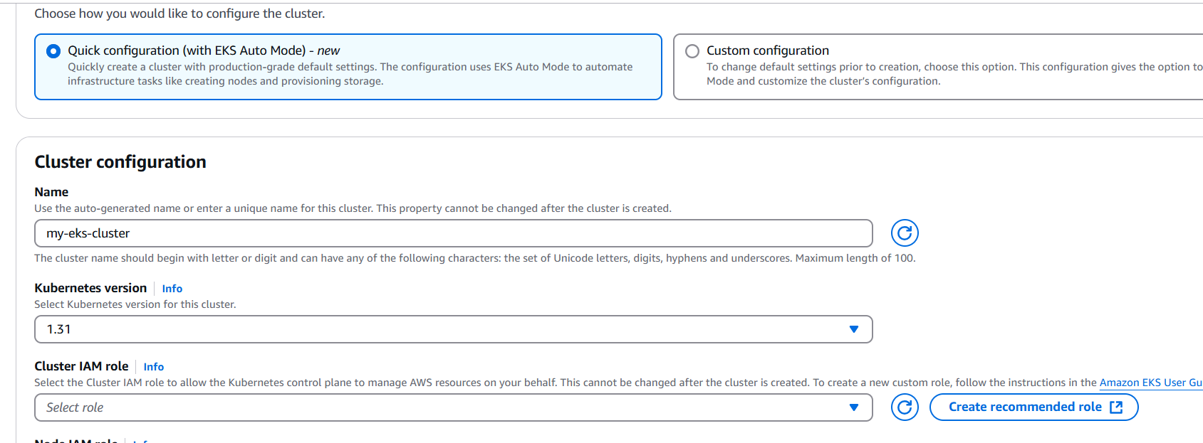

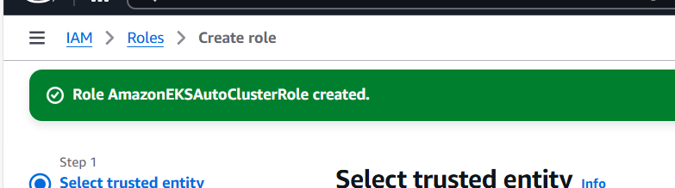

Choose the created role.

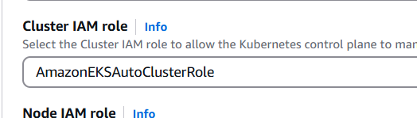

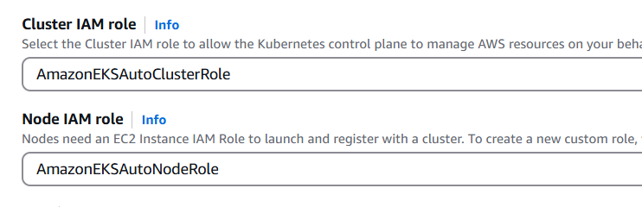

Choose VPC, subnets, and security groups

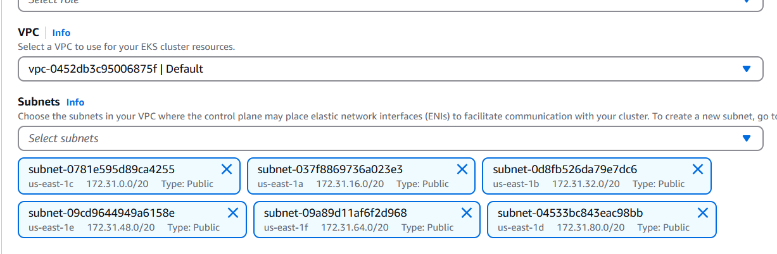

Click create cluster.

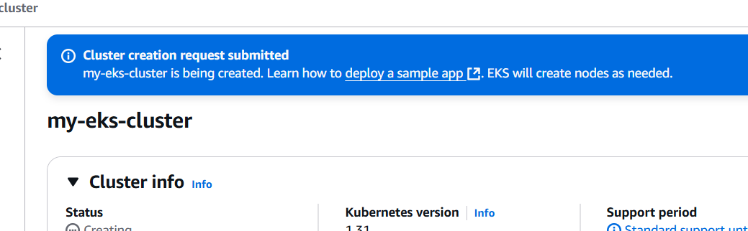

1. Click the cloud shell icon at the top right of the aws console.

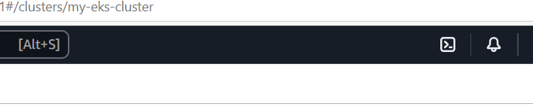

Run the following command to check configuration of AWS CLI

aws sts get-caller-identity

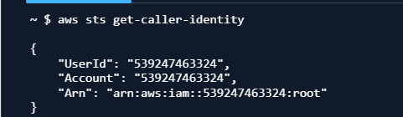

Update kubeconfig to connect to the cluster

aws eks --region us-east-1 update-kubeconfig --name my-eks-cluster

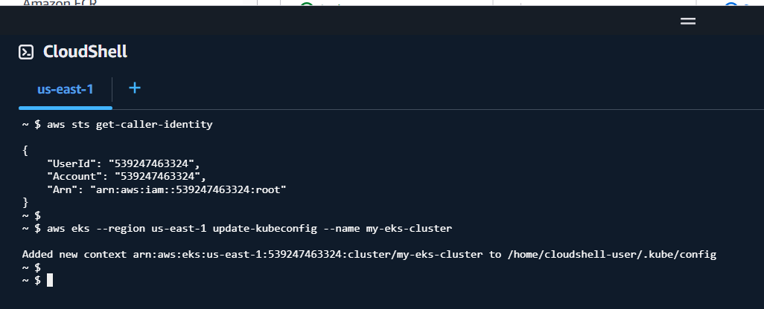

Verify the connection

kubectl get nodes

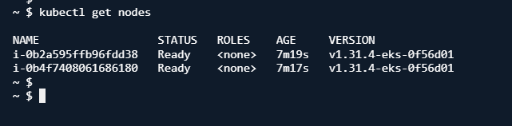

1. Create nginx deployment

kubectl create deployment nginx --image=nginx --replicas=2

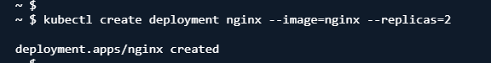

Verify the deployment

kubectl get pods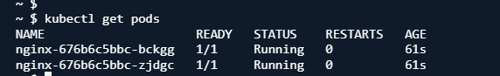

1. Expose the deployment using load balancer.

kubectl expose deployment nginx --type=LoadBalancer --port=80 --target-port=80



To get the external IP

kubectl get svc

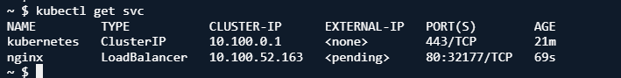

Once the external IP is displayed, copy and paste in the browser to check nginx welcome page.